Accessing data

Objectives
At the end of this session, the student will be able to:
- Use the SELECT statement
- Use the SELECT statement with the FROM clause
- Use the WHERE clause
- Use the various clauses used with SELECT
- Use of ORDER BY clause
- Work with typed and untyped XML
- Create, use, and view XML schemas
- Use of Xquery to access XML data

Part I – 60 Minutes
Exercise 1 : Use the SELECT statement with the various clauses.
This exercise will demonstrate the use of the SELECT statement with the various clauses such as FROM, WHERE, INTO, GROUP BY, HAVING and ORDER BY. You will use ST_EXAM database in Lab 03 and write appropriate queries:
- Write a query to return all the records from the Staff table.
- Write a query to return a list of all staff whose salary is greater than 5000. The result set should display ID, NAME, DEPT, JOB
- Company wants to give all its staff a yearly bonus of five percent of the salary. Write a query which will return the ID, NAME, DEPT, SALARY and the calculated yearly bonus. Store the result in another table call StaffBonus.
- Write a query to return the Name and Dept of all staff whose name starts with the letter 'S'.
- The management of the company wants to decide which departments need more manpower. Write a query which returns the number of staff in each department of the company.
- The management needs to know the total expense in salaries per department along with number of staff in that department. Write a query which returns the total salaries of all staff in each department which has number of staff greater than 2.
- Write a query to display all of staff whose year is greater than 5 and salary is 5000.
- Write a query to display all of staff whose salary column is sorted order.
- Write a query to display top 5 staff whose salary is highest.
- Display DEPT column in STAFF table that duplicate records do not appear.
Part II – 30 Minutes
Exercise 2 : Typed and untyped XML
- Typed XML
Create the following table:
Insert data iinto above table:
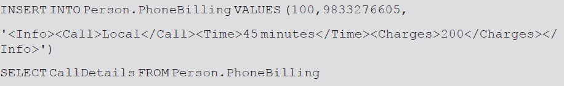
The output is shown
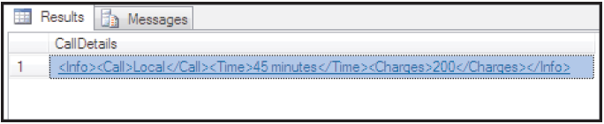
- Untyped XML
An XML instance which has a schema associated with it is called typed XML instance. The first step in using typed XML is registering a schema. This is done by using the CREATE XML SCHEMA COLLECTION statement as shown in Code Snippet.
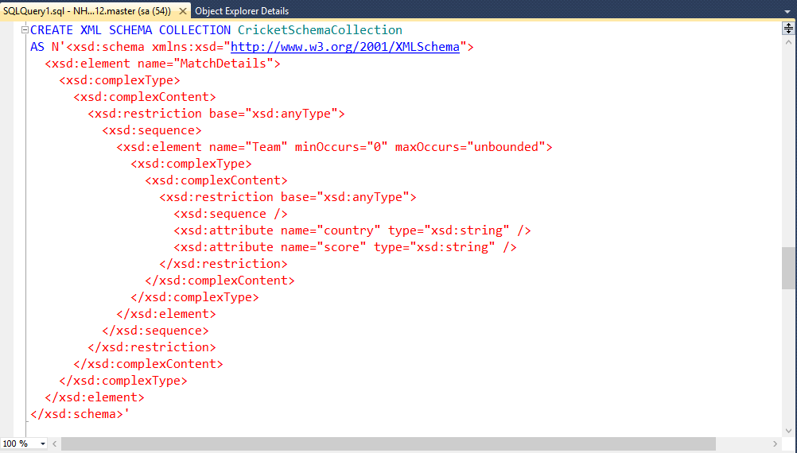
Create a table with an xml type column and specifies a schema for column:
To create new rows with typed XML data, the INSERT statement can be used:
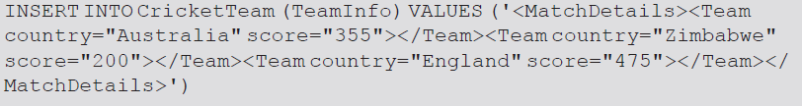
- XQuery
- exist()
This method is used to determine if one or more specified nodes are present in the XML document. It returns 1 if the XQuery expression returned at least one node, 0 if the Xquery expression evaluated to an empty result, and NULL if the xml data type instance against which the query was executed is NULL
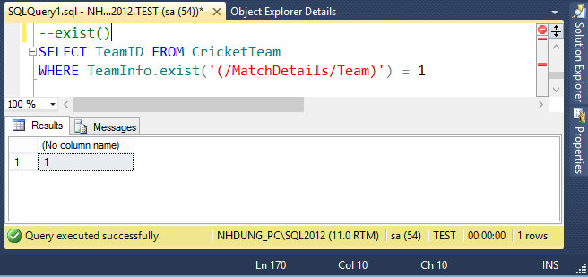
- query()
The query()method can be used to retrieve either the entire contents of an XML document or a selected section of the XML document. Code Snippet 28 shows the use of query()method.
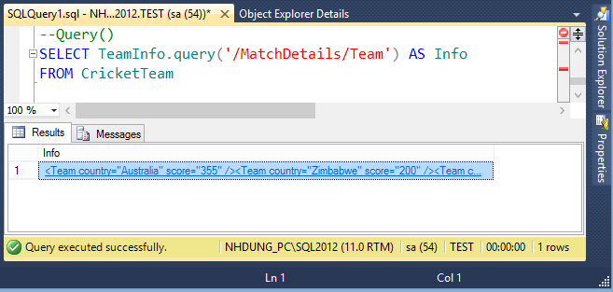
- value()
The value()method can be used to extract scalar values from an xml data type. Code Snippet 29 demonstrates this method.
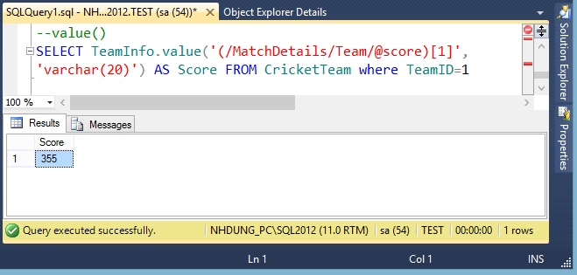

Part III – 30 Minutes
Using ST_EXAM database and write SQL statement to:
- Display all students who live in ‘TPCT’
- Display subjects that theory and lab are equal.
- Display students that exam time is 1 and has mark greater than or equal to 40
- Display students that have average mark greater than 50. The information included:
Rollno average of mark
- Display students that have exam ‘HDJ’ subject and exam in December.
- Display students that have exam ‘EPC’ and increase 10 percent mark of this subject for all of student. New column is named ‘increasing mark’.

